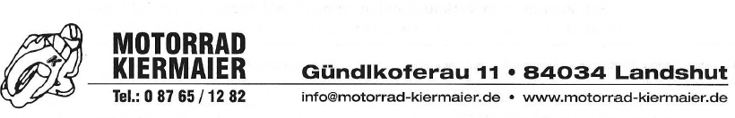
KTM Sonderpreisliste 2025
Modell: UVP: Sonderpreis:
1390 Super Duke R Evo 2024 | 23.994,00€ | 19.990,-€
1390 Super Duke R 2024 | 21.994,00€ | 18.490,-€
1290 Super Adventure R 2024 | 22.794,00€ | 18.490,-€
1290 Super Duke GT 2024 | 22.994,00€ | 15.990,-€
890 SMT 2024 | 15.495,00€ | 11.990,-€
890 Adventure 2024 | 15.685,00€ | 13.490,-€
390 Adventure 2024 | 7.594,00€ | 5.490,-€
390 Duke 2024 | 6.794,00€ | 6.290,-€
125 Duke 2024 | 5.994,00€ | 4.990,-€
890 Adventure R 2024 | 16.985,00€ | 13.990,-€
990 Duke 2024 | 14.985,00€ | 12.490,-€
390 Duke 2023 | 6394,00€ | 4.790,-€

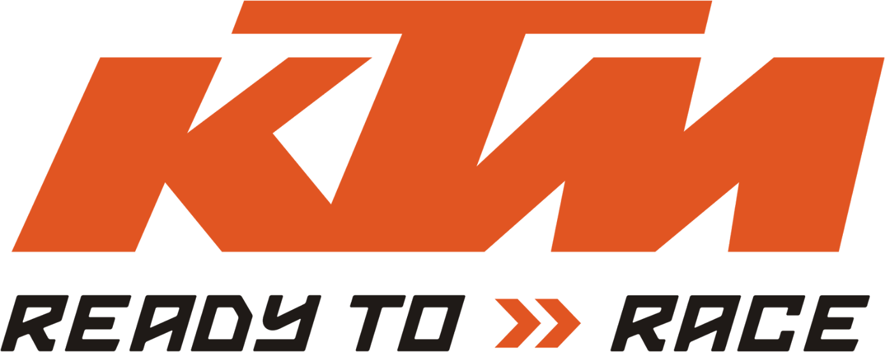
*Stand 20.02.2025, solange der Vorrat reicht!

